**Software Requirements Specification**

For

**SPORTS CONNECT**

Prepared by

|  |  |  |
| --- | --- | --- |
| **Specialization** | **SAP ID** | **Name** |
| CSE CCVT B2 | 500105975 | Sruti Sikha Goswami |
| CSE CCVT B2 | 500107226 | Harsh Jindal |
| CSE CCVT B3 | 500101645 | Garvit Goel |
| CSE CCVT B4 | 500106262 | Anil Joshi |



School of Computer Science

UNIVERSITY OF PETROLEUM & ENERGY STUDIES,

DEHRADUN- 248007. Uttarakhand

Table of Contents

|  |  |  |
| --- | --- | --- |
| **Topic** | |  |
| 1 | Introduction |  |
|  | 1.1 Purpose of the Project |  |
|  | 1.2 Target Beneficiary |  |
|  | 1.3 Project Scope |  |
|  | 1.4 References |  |
| 2 | Project Description |  |
|  | 2.1 Reference Algorithm |  |
|  | 2.2 Data/ Data structure |  |
|  | 2.3 SWOT Analysis |  |
|  | 2.4 Project Features |  |
|  | 2.5 User Classes and Characteristics |  |
|  | 2.6 Design and Implementation Constraints |  |
|  | 2.7 Design diagrams |  |
|  | 2.8 Assumption and Dependencies |  |
| 3 | System Requirements |  |
|  | 3.1 User Interface |  |
|  | 3.2 Software Interface |  |
|  | 3.3 Database Interface |  |
|  | 3.4 Protocols |  |
| 4 | Non-functional Requirements |  |
|  | 4.1 Performance requirements |  |
|  | 4.2 Security requirements |  |
|  | 4.3 Software Quality Attributes |  |
| 5 | Other Requirements |  |
| Appendix A: Glossary | |  |

**1. Introduction**

**1.1 Purpose of the Project**

- The project aims to develop a platform to bridge the gap in sports awareness in India, focusing on promoting sports other than cricket and providing athletes with better opportunities. It will offer information on various sports, training centers, and events while ensuring easy access and user engagement.

**1.2 Target Beneficiary**

The primary beneficiaries are athletes, sports enthusiasts, and sports academies. The platform also targets individuals interested in learning about diverse sports and connecting with training centers. Additionally, sports academies will benefit from increased visibility and user engagement.

**1.3 Project Scope**

- The platform will feature an easy-to-navigate interface with comprehensive sports information and a geolocation-based search to locate nearby sports academies and events. It will use cloud-based, serverless architecture for scalability and performance, implement machine learning algorithms for recommendations and content moderation, and ensure data privacy compliance.

**2. Project Description**

**2.1.1. Geolocation Algorithm**: Uses geospatial techniques to identify and recommend nearby sports academies and training centers based on the user's location.

**2.1.2. Recommendation Algorithm:** Collaborative filtering to suggest sports, academies, or articles based on user preferences and similar user behaviors.

**2.1.3. Content Moderation Algorithm:** Machine learning algorithms detect and filter spam or inappropriate user-generated content.

**2.1 Reference Algorithm**

**2.1.1. Geolocation Algorithm** : Uses geospatial techniques to identify and recommend nearby sports academies and training centers based on the user's location.

**2.1.2. Recommendation Algorithm** : Collaborative filtering to suggest sports, academies, or articles based on user preferences and similar user behaviors.

**2.1.3. Content Moderation Algorithm:** Machine learning algorithms detect and filter spam or inappropriate user-generated content.

**2.2 Data / Data Structure**

**2.2.1. Customer Data:** Includes user profiles, sports interests, location data, and search preferences.

**2.2.2. Sports Data:** Information on various sports, including rules, categories, and famous athletes.

**2.2.3. Operational Data:** Data about sports academies, training centers, locations, and events.

**2.2.4. Data Structure:** Uses graph-based data structures for geolocation features, hash maps for quick lookups of sports information, and document databases for user data.

**2.3 SWOT Analysis**

**2.3.1. Strengths:**

- Scalable architecture.

- Comprehensive sports content.

- Algorithms for recommendations and spam detection.

**2.3.2. Weaknesses:**

- Complexity in algorithm development.

- Privacy concerns.

**2.3.3. Opportunities:**

- Growing interest in fitness and sports.

- Partnerships with sports academies.

**2.3.4. Threats:**

- Competition from established platforms.

- Data privacy challenges.

**2.4 Project Features**

**2.4.1. User-Friendly Interface:** A simple and intuitive design for users to access information.

**2.4.2. Location-Based Search:** Geolocation-based search for nearby academies and events.

**2.4.3. Comprehensive Sports Database:** Information on a variety of sports, including niche and Olympic sports.

**2.5 User Classes and Characteristics**

**2.5.1** **Athletes and Sports Enthusiasts**: Seek information on sports and nearby training centers.  
**2.5.2 Sports Academies**: Use the platform for visibility and to attract potential trainees.  
**2.5.3 Administrators**: Manage content, oversee algorithm updates, and ensure data integrity.

**2.6 Design and Implementation Constraints**

2.6.1 Data Accuracy: The quality of recommendations depends on accurate user and location data.  
2.6.2 Scalability Requirements: Must support large user bases and traffic spikes.  
2.6.3 Security and Privacy Regulations: Compliance with data protection laws (GDPR, CCPA).  
2.6.4 Technology Stack: Uses HTML,CSS for frontend; Java for backend; MYSQL for data storage.

* 1. **Design Diagrams**

**2.7.1 Use Case Diagram**: Displays the interaction between bus operators and the system.

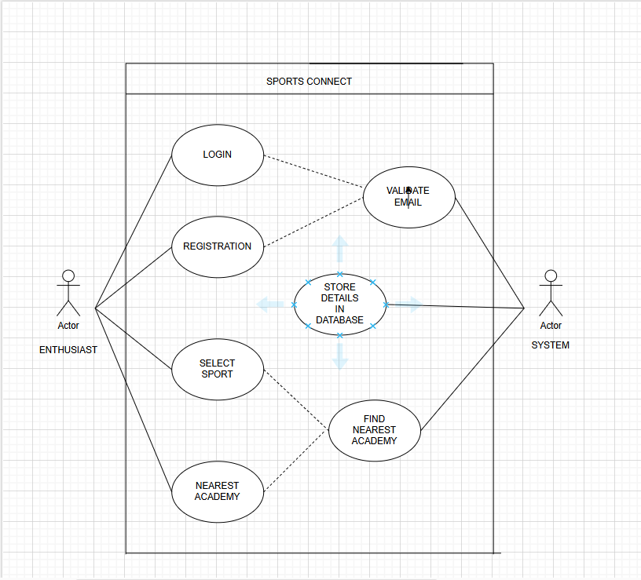

**2.7.2 Data Flow Diagram (DFD)**: Visualizes how customer data, booking data, and route details flow through the system.

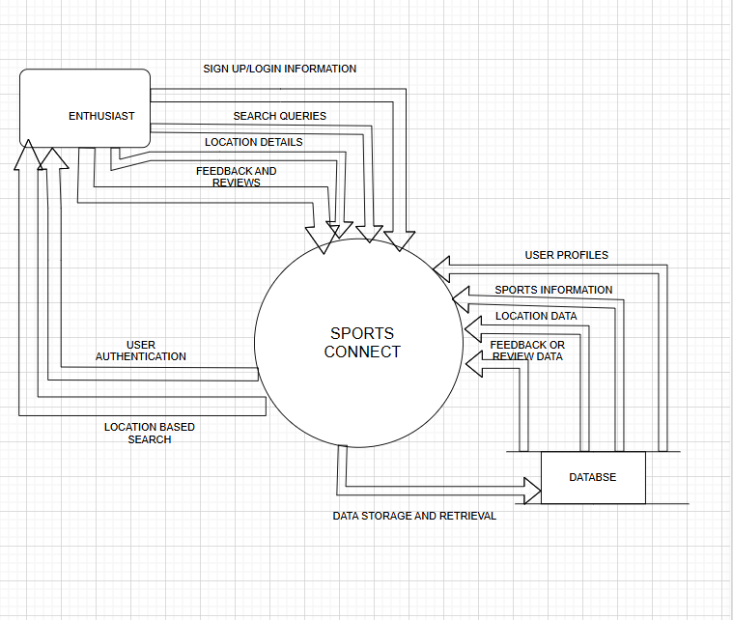

**2.8 Assumptions and Dependencies**

* The platform assumes consistent internet connectivity for users.
* It depends on reliable cloud services for deployment and data storage.
* Partnerships with sports academies are necessary for up-to-date information.

**3. System Requirements**

**3.1 User Interface**

* A responsive interface accessible via web browsers and mobile devices, with intuitive navigation for different user groups.

**3.2 Software Interface**

* Frontend: Use HTML/CSS.
* Backend: Implemented with Java on a serverless infrastructure

**3.3 Database Interface**

* MySQL for storing user profiles, sports data, and academy details.
* **3.4 Protocols**
* HTTPS for secure data transmission.
* REST for communication between frontend and backend services.

**4. Non-functional Requirements**

**4.1 Performance Requirements**

* The system should respond to user requests in under 3 seconds for a seamless experience.
* Route calculation and data fetching must be efficient to support large-scale usage.

**4.2 Security Requirements**

* Use encryption for sensitive data, including user details and location data.
* Implement multi-factor authentication for administrators.

**4.3 Software Quality Attributes**

* Scalability: Support increased users without degradation in performance.
* Maintainability: The system's codebase should be easy to update and extend.
* Reliability: Ensure a high availability rate (99.9% uptime).

**5. Other Requirements**

* The system should provide logs for audit trails and debugging.
* Backup mechanisms should be implemented to prevent data loss.

**Appendix A: Glossary**

* Geolocation: The process of determining the physical location of a user or device.
* MYSQL: A database used for storing data.